Choose one of the options from this menu:
1/2. Start a new daylight/night game try.
3. Restore a saved game state and play on.
0. Quit this game.
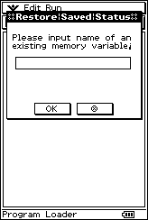
Inputting another choice will loop this box.
Please input name of an existing memory variable. Please note the fact that this dialog box will loop if you input list that does not have game format (that you can try to find it out from itself).
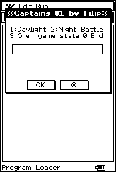
Please note that it is the first program that enables recursive matrix use, please see this code Matrix[Matrix[Element]], which is the element of the matrix which order number is element too!☺
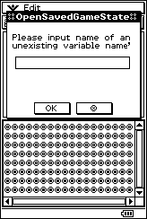
Please input name under which a list with the current game status will be saved. If you like, input nothing to cancel.
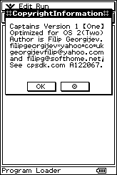
At the end, there are shown details about the author and program.

This program has:

In the MCS image, Captains.mcs, the native folder for this program is there Captains including 16 locked files: Captains (EXE) + captains (PRGM) (same contents) FilipGeo (LIST), & GeoFilip (LIST), with all the data for both the day & the night. Try!
Two game modes☺

Application goals?

Imagine, you are a captain of a ship – and it is attacked from another ships the time. You have to fire at them to survive longer–more the better!☺

Program functions

Use only, the hard arrow keys – as noted, to run this program. Press: [LEFT] to turn your view to the left, and: [RIGHT], to turn, your view, to the right. Press [UP] to shoot in the front of your view. Press [DOWN] to end the game, with the option, to save the game for future resume and convenience

P.S. There are 3 of the background screens, for both daylight, as well as nighttime battles and they mean: ‘sea is clear’, ‘☹–you must destroy the ship in front of you’ and: ‘the ship, is successfully destroyed’. You can also, shoot whenever you like, but in the meantime it is possible that 2 ships are approaching - from the 2 other views, that are not shown at the moment so that – you may, be killed from an invisible ship! ☺

P.S. P.S. Press the keys longer – for change!

P.S. P.S. P.S. Rare game with less shooting!

