What does this program include/feature? What are the application goals? See!
In the MCS image: Encyclop.mcs, there is the native folder for this program: Encyclop, which includes four locked files: Encyclop (EXE) and encyclop (PRGM) with same contents, as well as two list variables: FAST_CAR&fast_car with the lyrics data!
In the future, you might freely see this classification in a shop or on the Web:
CASIO > Musical Instruments > ClassPad 300... Are you looking all right now?
Your ClassPad 300 now has the technology implemented let’s say in Yamaha’s newest and best musical instruments, like the DiskClavier or the cool Tyros that take your breath away. What is the point about all this stuff? Now, you can save the lyrics that you do not know by heart for your favourite songs. Just play the music and read from the ClassPad 300 in real time what you have to sing along. You will look smart!
Well, this is surely one of the most unique programs, which I have created for the ClassPad 300, without any doubt. However, I must admit that I have been pretty lazy. You see, Fast Car is one of my favourite songs although it is very old. However, when I found the lyrics, for this song, I realized that was very long... I announce one bad thing: you will have to complete these files, by yourself. DIY! It is easy, you see:
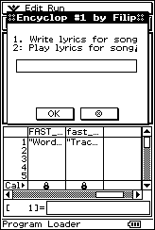
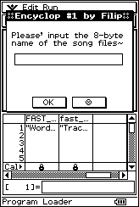
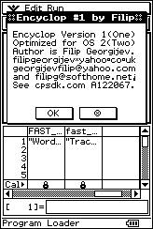
This program uses a smart algorithm for efficient and secure data storage. To create new song variables the Statistics List Editor is the best solution with no doubt. When you like, to play some lyrics, input the 8-byte name of the song. The ClassPad 300 automatically searches, for two twin list variables: the one in uppercase contains the verses, while the one in lowercase contains the waiting times between every two consequent verses. At first, the ClassPad 300, will display a message, which contains proprietary information of the song and its long name. This is already in FAST_CAR& fast_car. In the first variable, you have to add the verses as strings, each one in one single cell, starting from the second one (the first empty in this list). In the other list, you have to add the wait times, before every verse should appear, on the ClassPad’s screen. These have to be integers; be smart and use the hard keyboard only if it has any use at all on this machine. If everything is all right, the text window is displayed, and the program is paused. This is done not only to resize the window, if you like for your convenience, but also you should tap the pause icon in the same moment when the music starts playing. If the time is well coordinated, the first verse will be shown, shortly before you have to sing it, and this continues in the same manner with all the verses. At the end of the song the ClassPad 300 goes in a standby state; you maybe have to take all the air out of your chest to sing the last verse. Simply tap the screen anywhere you want or press some hard key to wake up your ClassPad 300! The end! P.S. If you notice, lists technology is used, to make wait time short, if compare to the time needed, to read/write in matrix. Enjoy this program!☺

