Congratulations☺
You have just run the twin brother of the Software-i.e.Hardware!
Select any one of the options & explore:
1. Encyclop built-in module from before.
2. Memories built in module from before.
3. Contrast built-in module from before.
4. Statistics Lists.
0. Quit program.
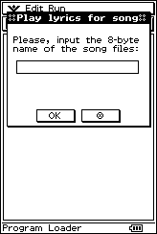
Enter here the 8-byte name of the song files, case is discarded now!
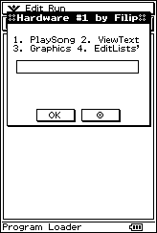
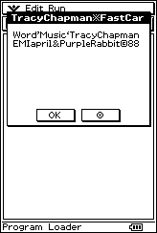
You can see the long name of the song and the author, as well as copyright information!
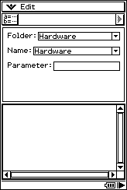
Resize the screen if you wish and tap the pause button exactly when the song starts!
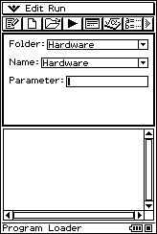
When the song ends, please tap the display or press any hard key!
Please input the name of an existing text variable, which is in fact a list of strings!
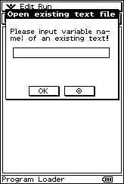
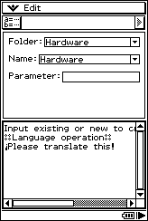
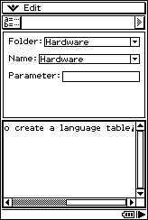
The text file required is given on the screen.
Tap the pausing button to go to before!
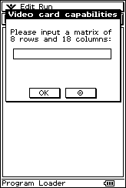
Please input a matrix of at least 8 rows and 18 columns extra rows and/or columns will be discarded for print!
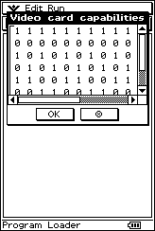
Here is the first matrix changed into graphics!
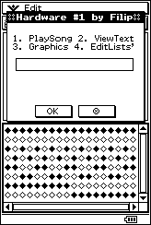
And here is the result!
Here is another of these matrix examples
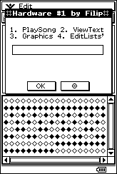
And here is the result!
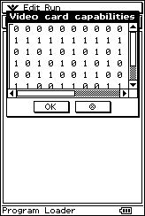
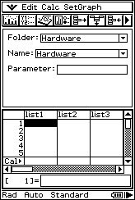
Here is the fourth of all these options – the Statistics List Editor!☺
Tap the pausing button to go to before!
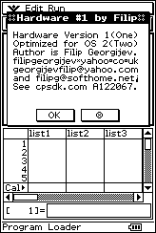
Read the message about version&author!

