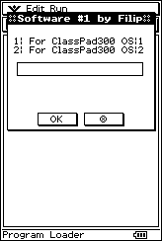
Congratulations!!!
You have just run the best program for the CASIO ClassPad 300. Do not feel afraid from the above, select any option to explore!
1: First submenu.
2: Second option.
0: Quit the using.
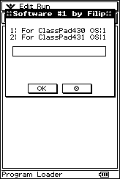
Select any of the given options and explore it!
1: First submenu.
2: Second option.
0: One level back.
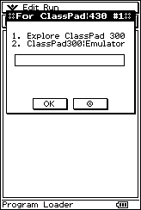
Select any of the given options and explore it!
1: First submenu.
2: Second option.
0: One level back.
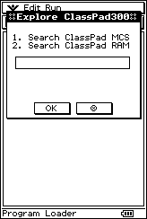
Select any of the given options and explore it!
1: SysTools built-in module from before.
2: FindFast built-in module from before.
0: One level back.
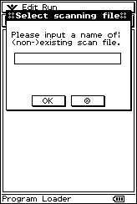
Please input a name of (non)existing scan file.
Inputting nothing will go one level back.
Input a variable name to be added to the list containing the variable types. Please remember that you have to input at least one variable name for the creation to finish. Otherwise, inputting nothing will continue to the next dialog box.
Input 1 if you like to be prompted before a variable deletion, or 0 if you do not like to be asked. Remember that inputting a number different from 1 or 0 will re-display the box.
Input 1 if you like to delete the variable, otherwise input 0. You cannot input anything else in the dialog box for stopping the loops.
The scanning results for each variable will appear on the display in real time. At last, the variable including all the results will be shown. You have good track on the activities!
Input variable name to save the results which were displayed before. Inputting nothing will discard all the results.
The program will pause so that you can scroll the text window if the number of items scanned was large. At the end, tap the pause button to continue on.
Please input variables names to which string scanning to be applied – inputting nothing will go one level back.
Input the keyword for which the variables will be scanned. Input nothing to go one level back. Input some text.
Input 1 if you like to negate the keyword, otherwise input 0. You cannot input anything else in the dialog box for stopping the loops.
Input 1 if you like to preview every found variable in a message box, otherwise input 0 – inputting anything else will loop this box.
This is a very nice example how does this algorithm work in real.
The variable including all the results will be shown. You have good track on the activities!
Input variable name to save the results which were displayed before. Inputting nothing will discard all the results.
Select any of the given options and explore it!
1: Emulator built in module from before.
2: Analyzer built-in module from before.
0: One level back.
Please input sequence of commands for the emulator, divided with semicolons among all. Input nothing to quit.
Here is given how this emulator works in reality – really perfect!
Please input only one calculation at a time, taking care that you do not input a catalog command or a crash will occur. Inputting nothing will close this module and go before.
Here is given how this emulator works in reality – really perfect!
Select any of the given options and explore it!
1: First submenu.
2: Second option.
0: One level back.
Select any of the given options and explore it!
1: AddressB built in module from before.
2: Research built-in module from before.
0: One level back.
Important Update
!!Breaking News:!!
The program will pause so that you can scroll the text window if the number of items scanned was large. At the end, tap the pause button to continue on.
The scan results for each variable will appear on the display in real time – perfectly!
Sorry for this, but this was done really at this point of research.
Important Update
!!Breaking News:!!
The program will pause so that you can scroll the text window if the number of items scanned was large. At the end, tap the pause button to continue on.
The calculation results for every of the expressions will go on the display in real time – that is so nice!
Sorry for this, but this was done really at this point of research.
Important Update
!!Breaking News:!!
The program will pause so that you can scroll the text window if the number of items scanned was large. At the end, tap the pause button to continue on.
The calculation results for every of the expressions will go on the display in real time – that is so nice!
Sorry for this, but this was done really at this point of research.
Important Update
!!Breaking News:!!
The program will pause so that you can scroll the text window if the number of items scanned was large. At the end, tap the pause button to continue on.
The scan results for each variable will appear on the display in real time – perfectly!
Sorry for this, but this was done really at this point of research.
Input a (non)existing entry name either to create or to view. Inputting nothing will move to previous box.
Input the first name for this brand new address file now!
Input the last name for this address entry.
Input the telephone № for this address entry.
Input the e-mailbox for this address entry.
Input the address for the new address entry.
The program will pause so that you can scroll the text window if the entries entered were long. At the end, tap the pause button to continue with work.
Regardless the window was old or new, at last the message is shown.
Welcome to the option for reverse exchange of variables between 2 CASIO ClassPads 300.
Please input 1 for giving requirements and getting variables, or 2 for getting orders and sending variables.
Inputting 0 will jump to previous box.
Please input variable name that you want to obtain at the machine.
Inputting nothing will terminate process.
Remember that at the end, the program will pause, to enable you to scroll through the window including the communication logins.
Select any of the options and explore it!
1: Interact built- in module from before.
2: Language built in module from before.
0: One level back.
Please enter number of touches of a screen, which is a hypothesis. Input nothing to quit.
Every time you touch the screen, the “busy” indicator changes the status. This indicates the number of touches of the screen. However you cannot ever get close to the input one.
Welcome to the first multi-language dialog ever written. Input an existing language data to change the settings, non-existing language data to create it or you can input nothing to jump one level before.
Translate this string and input the answer in the given entry box.
Translate now the string and input the reply in the given box.
Translate now the string and input the reply in the given box.
Select any of the given options and explore it!
1: First submenu.
2: Second option.
0: One level back.
Select any of the given options and explore it!
1: First submenu.
2: Second option.
0: One level back.
Select any of the given options and explore it!
1: Circuits built- in module from before.
2: Transfig built- in module from before.
0: One level back.
Important Update
!!Breaking News:!!
The program will pause so that you can scroll the text window if the entries entered were long. At the end, tap the pause button to continue with work.
Sorry for this, but this was done really at this point of research.
Please input the rays number of a given star that is to be changed into a ordinary n-gon. Input nothing to quit.
For the ray number 1.
For the ray – №2.
For the ray – №3.
For the ray of №4.
For the ray number 5.
This is the hardest problem that I could solve with my laptop. It seems really scary!
Please input a name under which the real Y_{F} matrix of the circuit will be saved to use it. Inputting nothing will discard all the results.
Do you believe that it can even give you the way how to connect the circuit required? It is really a cool feature!
Between 1 and 2.
Between points 1 & 3.
Between points 1 & 4.
Between points 1 & 5.
Between points 2 & 3.
Between 2 and 4.
Between points 2 & 5.
Between points 3 & 4.
Between points 3 & 5.
Between points 4 & 5.
Another example, there are now 3 rays.
Between rays 1 and 2.
Between rays 1 and 3.
Between rays 2 and 3.
Important Update Now
!!Breaking News:!!
As you can see from above, after was Transfig implemented into this software unit, I succeeded to come to one of the limitations of this machine, even running in a Manager.
As a result of this the group for OS build 2 had to be restricted.
I am really sorry, but CASIO should feel embarrassed for this.
Do not worry if you are in a labyrinth!
If you have this application, you will get out of it as quickly as possible! Very nice!
Input 1 if you are to solve a real maze problem, or 0 if you want to see how it can deal with a tiny maze.
You cannot input nothing–the box loops.
Enter a matrix which is either manually formatted in the input area, like [[0,1,0][0,1, 0][0,0,0]] or just enter the variable name, like Variable or variable. ☺
Input the start point where you are situated – full input protection.
When data is checked, you can see its status.
Input the rotation for seeking the exit when getting out of a maze.
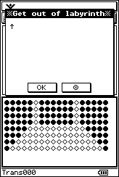
During the tries of getting out of the puzzle, you can get a visual experience of all the walls & corridors. At the end, there are shown real commands how to get out of this.
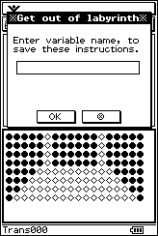
Enter a variable name, to save these valuable instructions. Inputting nothing deletes these.
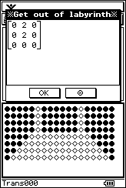
The solution of this puzzle is shown to see.
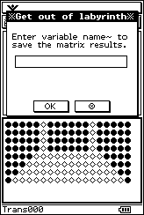
Enter a variable name, to save these valuable instructions. Inputting nothing deletes these.
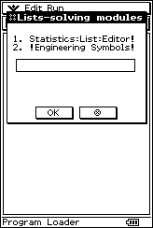
This is the last part of this package, since it is obvious that the stack of this machine is not large enough to support my programs!
Input 1 to start the module noted, 2 to preview information about the bonus tools, or 0 to go a level back.
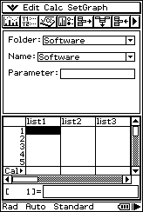
This only built-in application can be run from this module now!
Tap the pausing button to go to before.
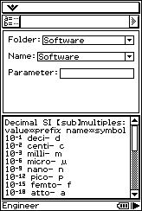
See about bonus tools!
Tap the pausing button to go to before.
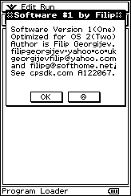
Congratulate to this absolute champion! ☺

